Ideation Phase
Define the Problem Statements
Date | 26 September 2026
Team ID | SWTID-2026-7148
Project Name | AI Weatherwise API
Maximum Marks | 2 Marks

Customer Problem Statement Template:
Create a problem statement to understand your customer's point of view. The Customer Problem Statement template helps you focus on what matters to create experiences people will love.
A well-articulated customer problem statement allows you and your team to find the ideal solution for the challenges your customers face. Throughout the process, you’ll also be able to empathize with your customers, which helps you better understand how they perceive your product or service.
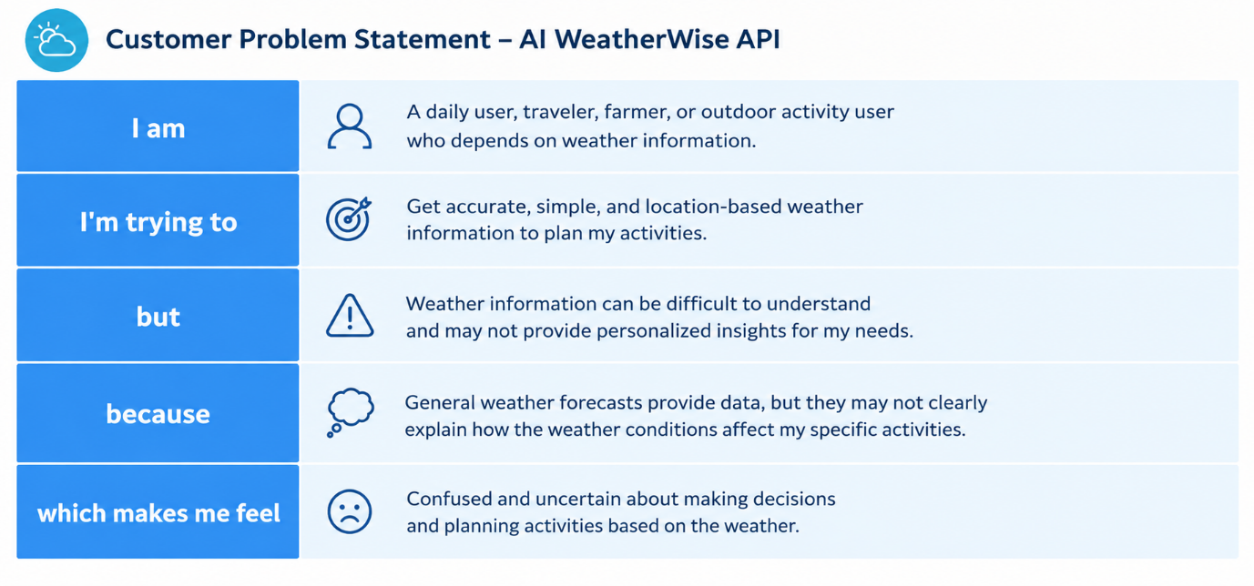
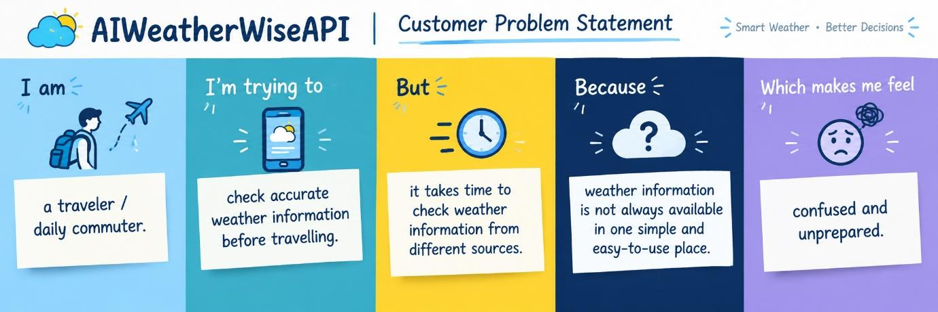
Example:
PS | I am | I’m trying to | But | Because | Makes me feel
PS-1 | a traveller | check weather | it takes time | information is scattered | confused
PS-2 | a daily commuter | know local weather | updates are not quick | data is from different sources | unprepared

